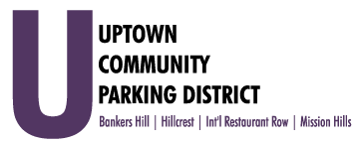
Executive Committee Meeting
Monday, June 7th, 2021 3:00PM
Farmer's Bottega, located at 860 West Washington

- Introductions & President’s report -Dahl

- Non-agenda Public comment
- Three-minute limit on non-agenda items

- February, March, April 2021 financial review -Earn

- BH election discussion -Dahl

- Circulate San Diego, CPD coalition letter

- Normal Street FY 22 Hillcrest MAD funding

- UCPD future meetings

- Review the proposed UCPD Board agenda -Dahl

Adjourn To Closed Session

