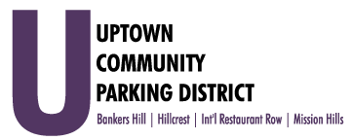
Special Meeting of the Bylaw Review Task Force
Thursday, November 18, 2021 4 -5:00 PM
Joyce Beers community Center
3900 Vermont St, 92103

Special Meeting of the Bylaw Review Task Force

- Introductions & President’s Report

- Public Comment
- Three-minute limit on non-agenda items

- Bylaw Review and Recommendations for Revisions

Adjourn

