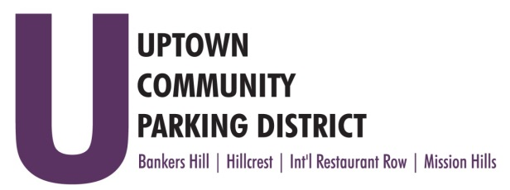
UPTOWN COMMUNITY PARKING DISTRICT
Bankers Hill Neighborhood Parking Committee Meeting
June 7, 2021; 5:00 PM – 6:00 PM
Virtual via Zoom

MINUTES

In Attendance: Doug Scott, John Knoll, Tom Fox, Peter Raymond, Curtis Allan
Excused:
Guest:

Scott: Called to Order 5:00pm and made Introductions
Non-Agenda public comment: Raymond would like a report on all the construction activity in the area, with no parking requirements, also pursue three compartment trash and recycling stations with doggie stations to combat the planters being used for disposal.

Chair’s report: Scott requested additional speed monitoring data information for the area. Fox provided an Executive Committee report.

Approve minutes May 3, 2021 Raymond/Scott

4th & 5th Bike lane construction continues, the contractors are making good progress.
The committee would like to confirm the style of bike racks to be installed are stainless steel half circles. Planting material is ready to go in. New lighting is well received.

Walk the Walk Update the 22 signs are installed on existing poles throughout the BH mobility area. Six additional signs for 6th Ave are needed, committee requests up to $2000.00 to fund.

Explore speed cushion locations, the committee would like to receive data compiled by the City monitoring stations to propose locations. Staff to check on speed monitoring data.

Complete FY 21
Crosswalks at Palm 4th & 5th
Crosswalks at Nutmeg and 6th

ADJOURN Fox/Raymond

