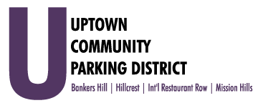
Closed Session Meeting of the Executive Committee
Monday, June 7th, 2021
Immediately following Executive Committee Meeting
Farmer's Bottega, located at 860 West Washington

Closed Session Meeting of the Executive Committee

1. Closed Session Meeting of the Executive Committee
Pursuant to Government Code Section 11126. (a) (1) Annual Review of Executive Director

Adjourn

