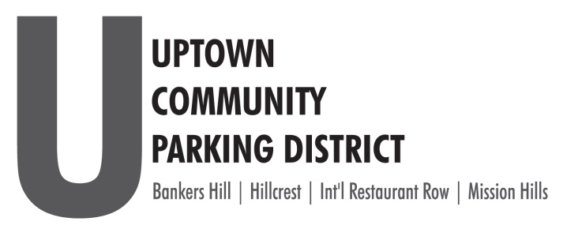
2021 BOARD of DIRECTORS
ELECTION NOMINATION FORM

The Uptown Community Parking District’s community partner, the Mission Hills BID have agreed to host our UCPD Board of Director’s elections, which are seeking a single representative from the business community of Mission Hills.
All elected directors serve a 3-year term.
The UCPD will ratify elections in November and seat the elected representatives at the December meeting.
Eligibility for Board Seat:
- Business owners or their agents or designated representatives operating within the boundaries Mission Hills AND that either: pay the City of San Diego business tax or are exempt from paying the City of San Diego business tax. Business owners or their agents shall only seek election from and represent the neighborhood in which their business is located.
Print Business Name:___________________________________________________________________

Nominee Name: _______________________________________________________________________

Title _________________________________________________________________________________
Please share your interests in serving on the UCPD Board:______________________________________
_____________________________________________________________________________________
_____________________________________________________________________________________
Business District, Mission Hills San Diego Business License Number
Address________________________________________________________________________

Phone_____________________________EMAIL_______________________________________________

Return this form by Friday, October 15, 2021 to Gerrie@ParkUptownSD.org

