REQUEST FOR QUALIFICATIONS & PROPOSAL

To: Maintenance & Landscape Service Providers Date: September 8, 2021
From: Gerrie Trussell
Subject: Bankers Hill 4th & 5th trash maintenance, watering and landscape service provider sought.
Request:
The Uptown Community Parking District (UCPD) is soliciting responses to this Request for Proposal to provide maintenance, watering and landscape services in Bankers Hill, 4th and 5th Avenue as defined in the attached scope of services.
Please forward any questions and responses to Executive Director, Gerrie Trussell at email Gerrie@ParkUptownSD.org
Background:
The City of San Diego (City) established Community Parking Districts in 1997 which are governed by City Council Policy 100-18. The Uptown Partnership, Inc., dba the Uptown Community Parking District (UCPD) is a 501(c) (3) public benefit non-profit organization that manages the UCPD via an annual agreement with the City. Each year, UCPD develops an Annual Plan & Budget for the Community Parking District that allocates parking meter revenues toward projects that are authorized by the City for the neighborhoods of Bankers Hill, Hillcrest, Mission Hills and International Restaurant Row.
Council Policy100-18: The intent of this Policy is to provide a mechanism whereby communities unable to meet existing parking demands may devise and implement parking management solutions to meet their specific needs and resolve undesirable parking impacts. This Council Policy, subsequent memorandums of law, City Municipal Code & Charter State and Federal Laws guide funding allocations and expenses which are reimbursable by the City for projects within the District.
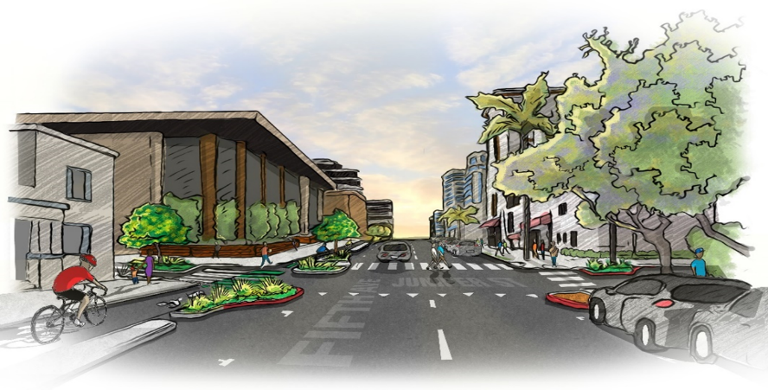
Location Map:
Bankers Hill
4th & 5th Avenues
Transportation Corridors
Description of Work / Scope of Service:
The UCPD is seeking a landscape maintenance service provider to provide three times a week trash removal for 46 trash receptacles. Provide watering and landscape services for planters including monthly fertilizer, litter removal and the replacement of plant material as needed.
The maintenance & landscape service provider will be responsible for all required insurance costs as well as all liabilities (see attached contractor Insurance requirement language). It is expected that this cost will be included in your quote. Contractor should be able to navigate and submit for any additional or extraordinary expenses of pre-approved materials or additional scope of work. See detail description for expanded scope outlined in “Attachment A”.
Trash Maintenance: 46 cans serviced three times a week.
Planters: 27 trees (Crepe Myrtle & Gold Medallion) 63 Planters 4th Avenue, 87 5th Avenue, Water, litter removal, replace bark, soil and plant material as needed. Monthly fertilizer.
Power washing trash receptacles: As needed, prior approval for increase billing/services needed.
Attachment A:
1. Empty trash receptacles by removing contractor supplied plastic liner. Replace with new trash bag, contractor supplied.
2. Wipe down and clean top (inside &outside) and all sides of trash receptacles, using a commercial grade all-purpose detergent, contractor supplied.
3. Cleaning and wiping shall be performed using contractor supplied clean or new commercial grade wiping cloths or disposable paper wipes.
These detailed specifications are critical to avoid disputes and substandard performance

Timelines:
The deadline for responses to this RFP, sent by email to Gerrie@ParkUptownSD.org is requested by September 27, 2021 at 5:00 PM. The Uptown Community Parking District expects to select a vendor by October 5, 2021 and anticipates that the consultant will begin providing Trash and Landscape services on October 15, 2021. It is anticipated this provider will run on a Month-to-Month basis for the first 3 months of service, with a service evaluation to be completed at the end of this 3 month period.
Request for Proposal Requirements:
I. General: The Request for Proposals should be concise, well organized and demonstrates the respondent’s qualifications and experience applicable to the project.
II. Contents: Statements submitted in response to this Request for Proposal shall be in the following order and shall include:
III. Maintain a two million General Liability policy, list the City and employees as well as the UCPD as additionally insured. Maintain workman’s comp insurance on all staff members.
A. Identification of the entity and identity of all principals
1. Legal name, website and address of company.
2. Legal form of entity (partnership, corporation, joint venture, etc.). If joint venture, identify the members of the joint venture and provide all information required within this section for each member.
3. Name, title, mailing address, telephone number, and e-mail address of the person to contact concerning the Request for Proposal.

Request for Proposal Requirements continued:

B. Experience and Technical Qualifications
Describe the contractor’s experience in completing similar projects. List at least three (3) successfully completed projects of a similar nature, together with the name of the client and project manager, telephone numbers, description of work performed, and value of the consulting contracts. Projects that are currently being performed may be submitted for consideration.
C. Knowledge and Understanding of Local Environment
Describe the contractor’s prior experience working with community groups in the San Diego area and its perceived ability to work closely with UCPD and City of San Diego’s staff.

D. Work Program
The contractor should describe how it proposes to accomplish the work identified in this RFQ. While the overall objectives and products of study described in the initial section of this RFQ (above) must be accomplished, the contractor may depart from the precise Scope of Services described above, subject to the approval of the UCPD. This detailed work program should be written and in an electronic format that is capable of being incorporated into the project Contract for Services.
E. Project Organization and Key Personnel
1. Describe proposed project organization, including the identification and responsibilities of key personnel. Indicate the role and responsibility of prime contractors and all sub-contractors.
2. Provide a description of the experience and professional licenses, if any, of the
contractor’s project team, including the team’s project manager, and other key staff members.
Previous and Current Contracts with the City of San Diego or their contracted community partners
i.e. BIDs, MADs etc.
F. Cost Estimates and Cost Breakdown provide an estimate of the total direct and indirect costs to complete the tasks identified in the Scope of Required Services (above). A cost breakdown should be provided identifying:
1) Number of staff hours and hourly rates for each team member; Rates should be presented hourly per employee, to include all fee employee wages, payroll tax, Workers Comp. insurance, General Liability Insurance, and off-street parking location costs.
2) Materials breakdown should consist of costs for maintenance and landscape service, water, bark,
disposal and all other supplemental costs.
3) An estimate of sub-contractor services, if needed.

Insurance Requirements:
Insurance. Contractor shall deliver to City, and shall ensure that each Subcontractor delivers to
City, a current certificate of insurance with attached policy endorsements for:

13.l Commercial General Liability Insurance, providing coverage for bodily injury, including death, personal injury, and property damage with limits of at least One Million Dollars ($1,000,000) per occurrence, subject to an annual aggregate of at least Two Million Dollars ($2,000,000);

  - Automobile Liability Insurance, providing coverage for all bodily injury and property damage, with a limit of at least One Million Dollars ($1,000,000) per occurrence. Such insurance shall cover liability arising out of any vehicle (including owned, hired, and non-owned vehicles) operated in performing any and all work pursuant to this Agreement. Coverage shall be written on ISO form CA 00 01 12 90, or a substitute form providing equivalent liability coverage; and

  - Workers' Compensation Insurance, as required by the laws of the State of California for all of Contractor's employees who are subject to this Agreement, with Employers' Liability coverage with a limit of at least One Million Dollars ($1,000,000).

Additional Insureds. Pursuant to a separate endorsement, "The City of San Diego, its elected officials, officers, employees, representatives, and agents “shall be named as additional insureds in all policies.

  - Primary & Non-Contributory. Insurance policies shall be endorsed such that the coverage is primary and non-contributory to any coverage carried or self-insurance maintained by City.

  - Qualified Insurer(s). All insurance required by the terms of this Agreement must be provided by insurers licensed to do business in the State of California which are rated at least "A­ ' VI" by the current AM Best Ratings Guide and which are acceptable to City. Non-admitted surplus lines insurers may be accepted provided they are included on the most recent list of California eligible surplus lines insurers (LESLI list) and otherwise meet City requirements.

  - Deductibles/Retentions. All deductibles and self-insured retentions on any insurance policy are the sole responsibility of Contractor, and must be disclosed and acceptable to City at the time evidence of insurance is provided.

Insurance Requirements Continued:

  - Continuity of Coverage. All policies shall be effective as of the Effective Date. The policies shall be kept in force for the duration of the Term. At least thirty (30) days prior to the expiration of each insurance policy, Contractor shall furnish a certificate(s) showing that a new or extended policy has been obtained which meets the requirements of this Agreement. Contractor shall provide proof of continuing insurance at least annually during the term of this Agreement. If insurance lapses or is discontinued for any reason, Contractor shall immediately · notify City and obtain replacement insurance as soon as possible.

  - Modification. To assure protection from and against the kind and extent of risk existing with the Project, City, at its discretion, may require the revision of amounts and coverage at any time during the Term by giving Contractor thirty (30) days prior written notice. Contractor shall also obtain any additional insurance required by City for changed circumstances or City's reasonable re-evaluation of risk levels related to the Project.

  - Accident Reports. Contractor shall immediately report to City any accident causing property damage or injury to persons and related to the Project. Such report shall contain the names and addresses of the involved parties, a statement of the circumstances, the date and hour of the accident, the names and addresses of any witnesses, and other pertinent information.

  - Causes of Loss - Special Form Property Insurance. Contractor shall obtain and maintain , at its sole cost , Causes of Loss - Special Form Property Insurance on all of Contractor's insurable property related to the Uptown CPD in an amount to cover 100 percent (100%) of the replacement cost. Contractor shall deliver to City a certificate of such insurance.
  - Subcontractors' Insurance. Contractor shall ensure that each Subcontractor complies with the insurance provisions of this Agreement as if the Subcontractor were Contractor. Contractor and each Subcontractor shall be individually responsible for obtaining and maintaining their own insurance.

Contractor Nominating and Selection Process:
- Based upon the submitted Request for Proposal, UCPD staff and committee members may identify a short-list of qualified contractors for this project. Should it find it to be in its best interest, UCPD reserves the right to make final contractor selection based solely upon evaluation of the written RFQs, without short-listing contractors or conducting oral interviews.
- UCPD staff and committee members may also interview the short-listed contractors. Based upon the RFQ and interview, staff will rank the finalists based on qualifications and recommend the selected contractor to the Board of Directors, which has final authority for selection.
- After this selection has been made, the UCPD will proceed to other negotiations with the entity. The negotiations will cover: scope of work, contract schedule, contract terms and conditions, technical specifications, and price. If the negotiating teams are unable to reach an acceptable agreement with the selected contractor, the negotiating team may recommend that negotiations be terminated, and that negotiations be initiated with the next ranked contractor.
- After negotiating a fair and reasonable proposed agreement, the UCPD Chief Operating Officer will
recommend its approval to the UCPD Board of Directors.
- The contract will then be submitted to the City of San Diego. Final authority to approve the agreement rests ultimately with the City of San Diego.

Proposal evaluation criteria:
Contractors will be considered and evaluated on the following criteria:
- Experience and technical qualifications of the contractor and potential subcontractors in completing maintenance and landscape related services;
- Prior experience of the participating contractors in completing joint projects, if sub-contractors are
proposed;
- Knowledge and understanding of the local environment;
IV. Adequacy of the proposed Detailed Work Program;
- Project Cost.

Special Conditions

I. Reservations
This Request for Proposal (RFP) is neither intended to expect to obligate UCPD to award a contract, or to defray any costs incurred in the preparation of a proposal pursuant to this RFQ, nor that UCPD nor the City of San Diego assumes any liability or responsibility (express or implied) arising out of this process.
No retroactive reimbursement will be made or considered for any costs incurred in preparing a response to this RFQ.

II. Public Records
All responses submitted to this Request for Proposals become the property of UCPD and its public records. As public records, these responses may be subject to public review following the selection of any contractor. The responses, however, will remain confidential during the review process.

III. Right to Cancel
UCPD reserves the unqualified right to cancel or modify, in whole or in part, this Request for Proposals, including the selection schedule, submittal date, and submittal requirements notice in writing.

IV. Compliance with Federal, State and Local Law
All respondents to this Request for Proposal agree to conform to existing State, Federal or local law relating to proposal disclosures and the ethical obligations required for all prospective contractors with public entities.

V. Additional Information
UCPD reserves the right to request additional information and/or clarification from all respondents’ submissions to this RFQ / RFP.

