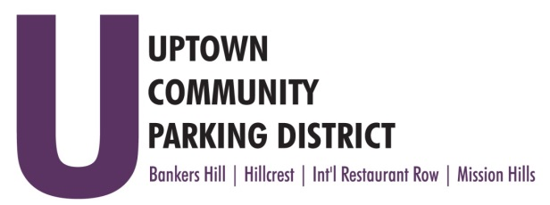
UPTOWN COMMUNITY PARKING DISTRICT
Bankers Hill Neighborhood Parking Committee Meeting
August 2, 2021; 5:00 PM – 6:00 PM
The Bellefontaine 2400 6th Avenue, 92103
MINUTES

In Attendance: Doug Scott, John Knoll, Tom Fox, Peter Raymond
Excused: Curtis Allan
Guest:
Staff: Gerrie Trussell
Scott: Called to Order 5:00pm and made Introductions
Non-Agenda public comment: Raymond reports plant material is dying and watering is occurring at hottest part of the day. Reports the bike lanes will have signals for bicyclists.
The organized bike rally in North Park had over 200 participants. Scott discussed HT Fenton to build out property on 5th Avenue, a possible grocery site with parking below. Traffic circles may be planned for Grape and Juniper at 6th Avenue.

Approve minutes June 7, 2021 Raymond/Fox

Future BHNPC meetings will be held in person for the foreseeable future.

4th & 5th Bike lane construction continues, the contractors are making good progress.
The committee will be issuing an RFP for maintenance services. The total should not exceed $65k, and will overseen by the UCPD until a MAD is formed in the BH area. The City will have final RFP review. Trussell to get referrals and 5 written proposals. Scott/Fox

Walk the Walk Update six additional signs were ordered are to be installed on existing poles throughout the BH mobility area.

UCPD City Contract was discussed and the requirement of anti-harassment and inclusivity training was approved by City Council. All Board will need to attend a training. The discussion of bylaw review was introduced and a City opinion is sought to establish eligibility and conflict of interests. The City can instruct and avoid unnecessary strife. All interested should participate in the bylaw committee at the Board level..

Complete FY 21
Crosswalks at Palm 4th & 5th
Crosswalks at Nutmeg and 6th
ADJOURN Fox/Raymond

