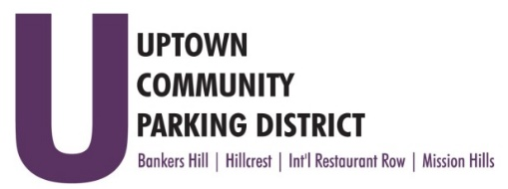
UPTOWN COMMUNITY PARKING DISTRICT
Board of Directors Meeting Agenda
March 14, 2022; 4:00 PM – 5:00 PM
Joyce Beers Community Center
3900 Vermont Street, 92103

- Establishment of Quorum, Call to Order and Introductions -Roy Dahl

- Non-Agenda public comment; Three minutes on non-agenda items

- President’s report (informational) -Roy Dahl

- Ratify HBA appointment Byron Ross,
To UCPD Hillcrest Business Board Seat (action item) -Ben Nicholls

- Review of December 13, 2021 Minutes (action item) -Tom Fox

- Review of Financials January 2022 (action item) -Miah Earn

- City Planning Department Presentation Q& A, focus plan amendment for the Hillcrest Community. As part of the focus plan amendment, the plan will identify transportation, land use, and urban design changes throughout the community. An Online Community Engagement Tool (OCET) Survey has been created to provide members of the community the opportunity to provide feedback and their thoughts on how they want the community to transition over the years.

- UCPD Audit, Sonnenberg CPA (action item) -Miah Earn

- UCPD FY 23 Budget (action item) -Miah Earn

- HPC, requests $2000.00 to create Bike collateral materials (action item) -Ben Nicholls

- IRR, requests $42,000.00 to install pedestrian lighting (action item) -Selina Stockley

- BHNPC, requests $35,000.00 for bike racks (action item) -Doug Scott

- Wayfinding Signs Maintenance Hillcrest and IRR $3500.00 (action item) -Ben Nicholls

- UCPD Bylaw Update Review

- Adjourn

