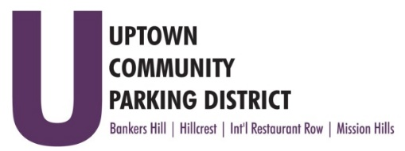
UPTOWN COMMUNITY PARKING DISTRICT
Board of Directors Meeting Agenda
April 11, 2022; 4:00 PM – 5:00 PM
Joyce Beers Community Center
3900 Vermont Street, 92103

- Establishment of Quorum, Call to Order and Introductions -Roy Dahl

- Non-Agenda public comment; Three minutes on non-agenda items

- President’s report (informational) -Roy Dahl

- Accept Resignation John Knoll BHNPC Business Board Seat (action item) -Doug Scott

- Review of March 14, 2022 Minutes (action item) -Tom Fox

- Review of January/February Financials 2022 (action item) -Miah Earn

- Letter of Support for a Hillcrest Community Benefit District (action item) -Ben Nicholls

- Hillcrest requests $250.00 Bike rack maintenance (action item) -Ben Nicholls

- Approve $1300.00 MFJ UCPD Taxes (action item) -Miah Earn

- UCPD Bylaw Update Review

- Committee Project Updates
Banker’s Hill -Doug Scott
Hillcrest -Ben Nicholls
International Restaurant Row -Selina Stockley
Mission Hills -Susan Mc Neil Schreyer

- Adjourn

