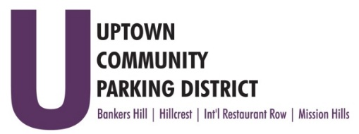
UPTOWN COMMUNITY PARKING DISTRICT
Board of Directors Meeting Agenda
May 9, 2022; 4:00 PM – 5:00 PM
Joyce Beers Community Center
3900 Vermont Street, 92103

- Establishment of Quorum, Call to Order and Introductions -Roy Dahl

- Non-Agenda public comment; Three minutes on non-agenda items

- President’s report (informational) -Roy Dahl

- Appoint Peter Raymond to an open BHNPC Business Seat (action item) -Tom Fox

- Review of April 11, 2022, Minutes (action item) -Tom Fox

- The National Association of American Planners (informational) -Tom Fox

- Normal Street Promenade Update (informational) -Ben Nicholls

- Approve and Publish the FY 21 Annual Report (action item)
Print 50 copies, up to $300.00

- Support for the “Hillcrest Little Spot” Concept (action item) -Ben Nicholls
Requests that the City and Cal Trans allow property to be used for place making and bike
way station.

- Anti -Harassment and Inclusivity Training, Friday, May 20th 1-5 pm Mandatory

- UCPD Bylaw Review Update

- Extend Officers eligibility, one year (action item)
Due to meeting cancellations during the Covid 19 pandemic, allow for a one-year exemption
to the 3-year maximum term for board officers.

- Committee Project Updates
Banker’s Hill -Doug Scott
Hillcrest -Ben Nicholls
International Restaurant Row -Selina Stockley
Mission Hills -Susan Mc Neil Schreyer

- Adjourn

