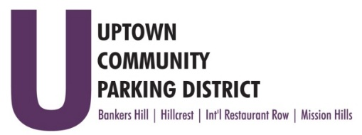
UPTOWN COMMUNITY PARKING DISTRICT
Board of Directors Meeting Agenda
June 13, 2022; 4:00 PM – 5:00 PM
Joyce Beers Community Center
3900 Vermont Street, 92103

- Establishment of Quorum, Call to Order and Introductions -Roy Dahl

- Non-Agenda public comment; Three minutes on non-agenda items

- President’s report (informational) -Roy Dahl

- Peter Raymond Resignation from BHNPC Resident Seat
Appointment to BHNPC Business Seat (action item) -Doug Scott

- Review of May 11, 2022, Minutes (action item) -Tom Fox

- Review Financials: March & April 2022 (action item) -Miah Earn

- Accept Bylaw ad hoc committee recommended changes
Final vote will take place 30 days after ad placement per current UCPD Bylaws (action item) -Roy Dahl

- Approve Ad Placement for Bylaw Notice $500.00
Bylaw Revisions, Bylaw Taskforce Recommendations (action item) -Roy Dahl

- Bankers Hill requests $4000.00 to do planned Extraordinary Maintenance (action item) -Doug Scott

- Executive Director Review (action item) -Roy Dahl
Recommend 4% salary increase

- Request to return the UCPD Board meeting to 3 pm. (action item) -Roy Dahl

- ParkUptownSD.org – security, updates, plug ins $600.00 (action item) -Roy Dahl

- Anti-Harassment and Inclusivity Training (informational) -Roy Dahl

- Committee Project Updates
Banker’s Hill -Doug Scott
Hillcrest -Ben Nicholls
International Restaurant Row -Selina Stockley
Mission Hills -Susan Mc Neil Schreyer

- Adjourn

