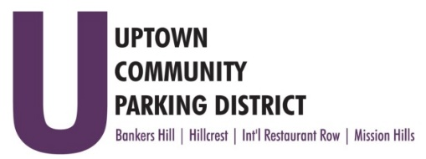
UPTOWN COMMUNITY PARKING DISTRICT
Board of Directors Meeting Agenda
July 11, 2022; 3:00 PM – 4:00 PM
Joyce Beers Community Center
3900 Vermont Street, 92103

- Establishment of Quorum, Call to Order and Introductions -Roy Dahl

- Non-Agenda public comment; Three minutes on non-agenda items

- President’s report (informational) -Roy Dahl

- Review of June 13, 2022, Minutes (action item) -Tom Fox

- Review Financials: May 2022 (action item) -Miah Earn

- Normal Street Promenade Update (informational) -Brittany Bailey

- Executive Director Review (action item) -Roy Dahl
Recommend 3% IRA match

- August UCPD meeting cancelled (informational) -Roy Dahl

- Anti-Harassment and Inclusivity Training (informational) -Roy Dahl

- Committee Project Updates
Banker’s Hill -Doug Scott
Hillcrest -Ben Nicholls
International Restaurant Row -Selina Stockley
Mission Hills -Susan Mc Neil Schreyer

- Adjourn

