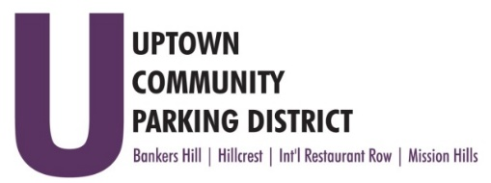
UPTOWN COMMUNITY PARKING DISTRICT
Board of Directors Meeting Agenda
September 12, 2022; 3:00 PM – 4:00 PM
Joyce Beers Community Center
3900 Vermont Street, 92103

- Establishment of Quorum, Call to Order and Introductions -Roy Dahl

- Non-Agenda public comment; Three minutes on non-agenda items

- President’s report (informational) -Roy Dahl

- Allen Resignation, due to business closure (action item) -Doug Scott
- Review of July 11, 2022, Minutes (action item) -Tom Fox

- Review Financials: June 2022 (action item) -Miah Earn
Year End Report: FY 22 Budget, Cash Flow
Meter Revenue Comparisons 2019- 2022

- Audit, Sonnenberg $4,500.00 (action item) -Miah Earn

- Hillcrest Bollard Project $ 17,954.34 (action item) -Ben Nicholls
Purchase 18 bollards for use in Placemaking. Locations are at intersecting alleys between 4th and 5th
Avenue from Washington to Robinson. Core 32 locations at above sites for storage and placement.

- Bylaw Revisions (action item) -Roy Dahl
Uptown News ad link: https://cdn.sdnews.com/wp-content/uploads/20220805114617/Uptown-News-Archive-2022-08-05.pdf?_ga=2.231561820.2118624348.1662569281-1350229315.1662569278

- Elections, approve display ad to run October in the Uptown News $539.00. (action item) -Roy Dahl

- Bankers Hill Juniper Art Project (informational) -Doug Scott
A Placemaking project to install a street art mural on Juniper. BHNPC approved sending out artist RFQ.

- Committee Project Updates
Banker’s Hill -Doug Scott
Hillcrest -Ben Nicholls
International Restaurant Row -Selina Stockley
Mission Hills -Susan Mc Neil Schreyer

- Adjourn
3

