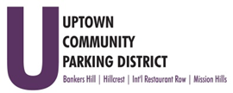
Hillcrest Parking Committee
Thursday, October 27, 2022, 3 pm - 4 PM
At The HBA offices
1601 University Avenue, 92103
Note: There are no public restrooms at this facility.

- Introductions

- Non-agenda public comment
Comments are taken from the public on items that are not on the agenda 2 minutes per speaker.

- Review Minutes – September 2022

- Explore Digital
AccessHillcrest.com and social media presentation: November 2022
Campaign proposal review/update

- Explore Offering a Hillcrest Sunday Shuttle Service,
Review Bids
Route/Times

- Bollards for Mural Alley Installation
Review core sample information/ footings
Dig, demo and pour 32 12inch footings- RFP
DSD consultation

- Parking Conversion Request
3900 block of Fifth Avenue - Convert yellow loading zone to green zone, business request.

Adjourn

