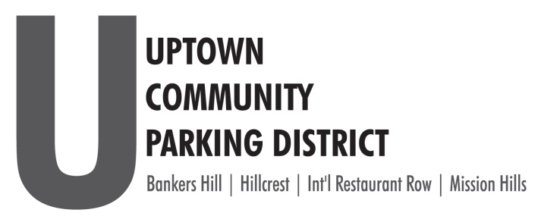
2022 BOARD NOMINATION FORM

The Uptown Community Parking District’s community partners, the Hillcrest Business Association and the Hillcrest Town Council have agreed to host our UCPD Board of Director’s elections seeking a single resident representative and two from the business communities of Hillcrest.
The Uptown Community Parking District’s community partners, the Bankers Hill Community Group have agreed to host our UCPD Board of Director’s elections seeking a two representatives from the residential, and two from the business community of Bankers Hill.
All nominated directors serve one, 3-year term.
The UCPD will confirm elections and seat elected representative at the November 2022 board meeting.
Eligibility for Board Seat:
- Business owners or their agents or designated representative operating within the boundaries of Bankers Hill, and Hillcrest that either: pay the City of San Diego business tax, or are exempt from paying the City of San Diego business tax; or that pay the City of San Diego rental tax. Business owners or their agents shall only seek election from and represent the neighborhood in which their business is located.

- Residents must be able to show proof of residency in the neighborhood they represent.

Print Name____________________________________________________________________

___Business Nominee ______________________________________________(Business Name)
Title _________________________________________________________
___Resident Community _____Bankers Hill _____Hillcrest

Address________________________________________________________________________

Phone_____________________________EMAIL_______________________________________________
Please fill out and return this form to the HBA, HTC, BHCG or Gerrie@ParkUptownSD.org

