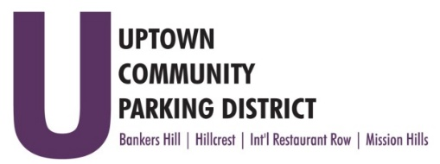
UPTOWN COMMUNITY PARKING DISTRICT
Board of Directors Meeting Agenda
October 10, 2022; 3:00 PM – 4:00 PM
Joyce Beers Community Center
3900 Vermont Street, 92103

- Establishment of Quorum, Call to Order and Introductions -Roy Dahl

- Non-Agenda public comment; Three minutes on non-agenda items

- President’s report (informational) -Roy Dahl

- Review of September 12, 2022, Minutes (action item) -Tom Fox

- Review Financials: July 2022 (action item) -Miah Earn

- Bylaw Revisions (action item) -Roy Dahl
Uptown News ad link: https://cdn.sdnews.com/wp-content/uploads/20220805114617/Uptown-News-Archive-2022-08-05.pdf?_ga=2.231561820.2118624348.1662569281-1350229315.1662569278

- UCPD Elections (informational) -Roy Dahl
HBA / HTC October 11th 5-6 pm at 1601 University Avenue
BHCG October 17th 6:30 -7:00 pm 3030 Front Street

- Hillcrest Communication allocation to Explore Digital $44,000.00 (action item) -Ben Nicholls
The contract scope will include social media posts and boosts, a website refresh and monthly blog.

- Bankers Hill parking conversions, postage funding allocation $300.00 (action item) -Doug Scott
for public/community notifications.

- Bankers Hill Juniper Art Project (informational) -Doug Scott
A Placemaking project to install a street art mural on Juniper. BHNPC artist RFQ award.

- Committee Project Updates
Banker’s Hill -Doug Scott
Hillcrest -Ben Nicholls
International Restaurant Row -Selina Stockley
Mission Hills -Susan Mc Neil Schreyer

- Adjourn

