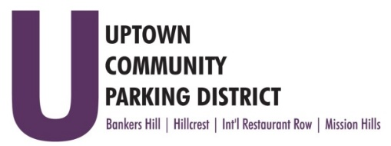
UPTOWN COMMUNITY PARKING DISTRICT
Board of Directors Meeting Agenda
November 14, 2022; 3:00 PM – 4:00 PM
Joyce Beers Community Center
3900 Vermont Street, 92103

- Establishment of Quorum, Call to Order and Introductions -Roy Dahl

- Non-Agenda Public Comment; Three minutes on non-agenda items

- President’s Report (informational) -Roy Dahl

- Review of October 10, 2022, Minutes (action item) -Tom Fox

- Review Financials: August 2022 (action item) -Miah Earn

- Ratify UCPD Elections (action item) -Roy Dahl
Seat Karl Domond, Michael Meacham
Elected for another term Tom Fox, Doug Scott, Ben Nicholls, Chris Shaw and Roy Dahl

- Hillcrest, DSD Ministerial Review for Bollard Placement $6500.00 (action item) -Ben Nicholls
Advised by City staff, the HPC will request a ministerial review for the Mural Alley Bollard Project.
This will allow City engineers to review and advise engineering attention needed to multiple areas of the project while in the permitting phase.

- Holiday UCPD Meeting Schedule (action item) -Roy Dahl
HPC – Thursday, Nov 17th, 3 pm
UCPD Executive - Monday Dec 5th, 3 pm
BHNPC -Tuesday, Dec 6th, 3 pm
UCPD Board of Directors – Monday, Dec 12th, 3 pm
HPC – Thursday, Dec 15, 3 pm

- Committee Project Updates
Banker’s Hill -Doug Scott
Hillcrest -Ben Nicholls
International Restaurant Row -Selina Stockley
Mission Hills -Susan Mc Neil Schreyer

- Adjourn

