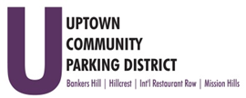
Hillcrest Parking Committee
Thursday, January 26, 2022, 3 pm - 4 PM
At The HBA offices
1601 University Avenue, 92103
Note: There are no public restrooms at this facility.

- Introductions

- Non-agenda public comment
Comments are taken from the public on items that are not on the agenda 2 minutes per speaker.

- Review Minutes – November 2022

- Kiosk Damage – Normal St.
Police report, Insurance claim, repair

- AccessHillcrest.com and social media activities
Discuss next steps- Service

- Hillcrest Sunday Shuttle Service,
Rec Rental, Start/Route/Times

- Big Picture Hillcrest Town Square
Discuss rendering of space and use
Bollards for Mural Alley Installation

8. Budget FY 24
Budget Worksheets and Project Narratives

- Parking Conversion Request

Adjourn

