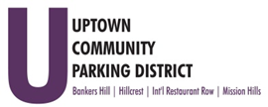
Hillcrest Parking Committee
Thursday, May 25, 2023, 3 pm – 4pm
At The HBA offices
1601 University Avenue, 92103
Note: There are no public restrooms at this facility.

- Introductions

- Non-agenda public comment
Comments are taken from the public on items that are not on the agenda 2 minutes per
speaker.

- Review Minutes – April 2023

- City Council Normal St / Pride Plaza

- Alternative Transit Education & Outreach
- Bicycle route promotion: Info inclusion, map, window clings and additional materials, QR code, platform optimization, and distribution details
- Bus route promotion: Social media and public awareness

- Extraordinary Maintenance FY23

- Hillcrest Little Spot update

- 400 Block of University Pedestrian Light Canopy

- Conversion Request

Adjourn

