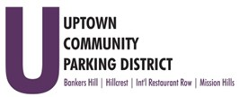
Hillcrest Parking Committee Thursday, January 18, 2024, 3 pm – 4 pm
At The HBA offices
1601 University Avenue, 92103
Note: This facility has no public restrooms.

- Introductions

- Non-agenda public comment
Comments are taken from the public on items not on the agenda,
2 minutes per speaker.

- Transportational Element Hillcrest Plan Update

Adjourn

