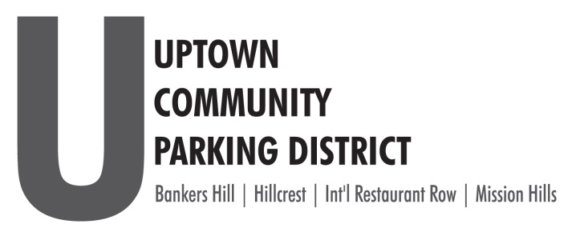
2024 BOARD NOMINATION FORM
DEADLINE: Monday, September 30, 2024, at 5 p.m.

The Uptown Community Parking District’s community partners, the Hillcrest Business Association and the Hillcrest Town Council have agreed to host our UCPD Board of Director’s elections seeking a single resident representative and two representatives from the business communities of Hillcrest.
The Uptown Community Parking District’s sub-committee International Restaurant Row Parking Advisory Committee is electing a representative from the business community to serve on the UCPD Board of Directors.
All nominated directors serve one, 3-year term.
The UCPD will confirm elections and seat elected representative at the November 2024 board meeting.
Eligibility for Board Seat:
- Business owners or their agents or designated representative operating within the boundaries of Hillcrest or Bankers Hill, or Mission Hills within the Parking district boundaries that either: pay the City of San Diego business tax or are exempt from paying the City of San Diego business tax; or that pay the City of San Diego rental tax. Business owners or their agents shall only seek election from and represent the neighborhood in which their business is located.

- Residents must be able to show proof of residency in the neighborhood they represent.

Bankers Hill: 1 Business Seat, Hillcrest: 2 Business Seats, Mission Hills: 1 Business Seat
Print Name of Nominee____________________________________________________________
Circle one: Bankers Hill, Hillcrest, Mission Hills
____Business Nominee ______________________________________________(Business Name)

Business Address________________________________________________________________________

Phone_____________________________EMAIL______________________________________________
Please fill out and return this form to the HBA, Gerrie@ParkUptownSD.org
DEADLINE: Monday, September 30, 2024, at 5 p.m.

