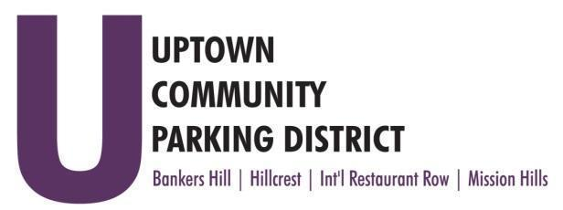
UPTOWN COMMUNITY PARKING DISTRICT
Board of Directors Meeting Agenda
January 13, 2025; 3:00 PM – 4:00 PM
Joyce Beers Community Center
3900 Vermont Avenue Street, 92103

Establishment of Quorum, Call to Order, and Introduction Nicholls

- Non-Agenda public comment
Three minutes on non-agenda items

- Reports:
President’s Report (Information) Nicholls
Executive Director’s report

- Approve October 14, 2024, UCPD Minutes (Action) Dahl
- Treasurer's report (Action) McNeil Schreyer
- Approve October and November 2024 financial review

- UCPD Elections, Accept and Seat Members (Action) Nicholls

- Elect UCPD Officers (Action) Nicholls

- Restrict food trucks & vending in the Hillcrest Cultural District (Action) Nicholls

- Bankers Hill Wayfinding Contract Award (Action) Scott

- IRR Light Annual Maintenance (Action) Rabinowitz

- IRR Decals, final design (Action) Rabinowitz

- UCPD Annual Audit (Sonnenberg CPA) and Taxes (MFJ Systems) (Action) McNeil Schreyer

- Parking Conversions (Action) Trussell
Fir 3rd-4th four spaces to eight
Vermont from Pennsylvania to Cypress from 10 to 13 spaces
Eagle St. between West Lewis to Ft Stockton from 8 to 12 + 1 ADA
1600 Blk. West Lewis & Stephens St. implementation of time limited two green zones

- Normal Street Promenade update (Information) Nicholls

Adjourn

