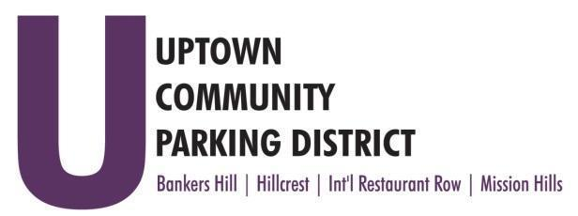
UPTOWN COMMUNITY PARKING DISTRICT
Board of Directors Meeting Agenda
February 10, 2025; 3:00 PM – 4:00 PM
Joyce Beers Community Center
3900 Vermont Avenue Street, 92103

Establishment of quorum, call to order, and introduction Nicholls

- Non-agenda public comment
Three minutes on non-agenda items

- Reports:
President’s report (Information) Nicholls
Executive Director’s report

- Approve January 13, 2025, UCPD minutes (Action) Raymond
- Treasurer's report (Action) Meacham
- Approve December 2024 financial review
- Discussion of proposed Standard Operating Procedures

- Presentation Normal Street Promenade groundbreaking (Information) SANDAG/Bailey

- Letter to restrict food trucks/vending in the Hillcrest Cultural District (Action) Nicholls

- Deliberation concerning City changes to 100-18 and 200-4 (Action) Nicholls

Adjourn

