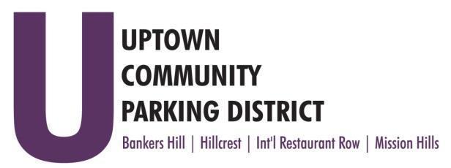
UPTOWN COMMUNITY PARKING DISTRICT
Board of Directors Meeting Agenda
May 12, 2025; 3:00 PM – 4:00 PM
Joyce Beers Community Center
3900 Vermont Avenue Street, 92103

Establishment of quorum, call to order, and introduction Nicholls

- Non-agenda public comment
Three minutes on non-agenda items

- Reports:
President’s report (Information) Nicholls
Executive Director’s report (Information) Trussell

- Approve April 14, 2025, UCPD minutes (Action) Raymond
- Treasurer's report (Action) Meacham
- Approve March 2025 financial review

- DMV Lease and application fee (Action) Nicholls
- Diversity and inclusion proposed bylaws changes (Action) Nicholls

- Goldfinch, MH parking conversions (Action) McNeil Schreyer

- Bankers Hill construction impact on meters (Information) Meacham

- UCPD FY 26 budget, City contract, partnering with a fiscal agent,
and revisions to 100-18" (Action) Nicholls

Adjourn

